Digital Marketing

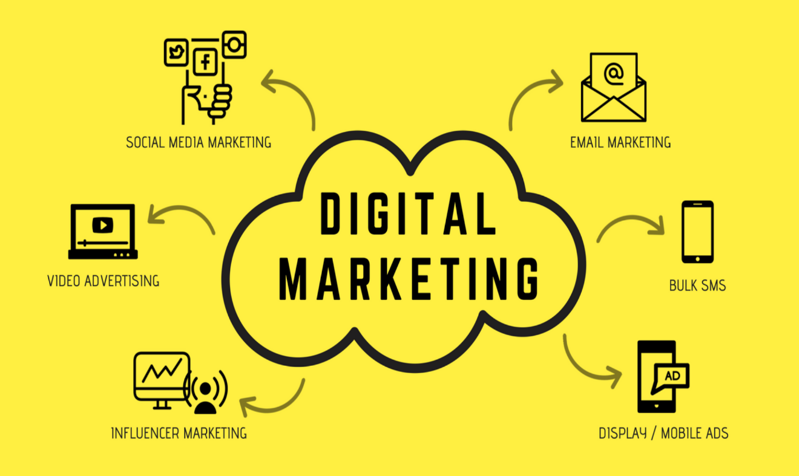

**| Foundation of Information Technology and Applications |**

Submitted by: - **Sakira Tandukar**

Section: - **“A”**

Roll. No: - **22**

Batch: - **BIM 1st Sem**

1. **Abstract**

Digital marketing is a rapidly evolving field that leverages online platforms to promote brands, products, and services. This project aims to explore the impact of digital marketing on businesses, understand key strategies, and analyze the opportunities and challenges faced in the digital space. Through research and case studies, we will assess the effectiveness of digital marketing techniques and provide insights into its future growth.

1. **Introduction**

Digital marketing refers to the use of online platforms and digital technologies to promote products and services. It encompasses a variety of channels, including email, social media, web-based ads, and multimedia messages, to connect with potential customers. The digital era has transformed the way businesses interact with customers. Traditional marketing methods are being replaced with digital channels such as social media, search engines, email marketing, and influencer collaborations. The global shift towards online engagement makes digital marketing an essential tool for businesses of all sizes.

With the rise of e-commerce and online interactions, companies must establish a strong digital presence to remain competitive. Digital marketing provides businesses with measurable data to track user behavior, engagement levels, and conversion rates. This data-driven approach allows companies to tailor their marketing strategies and allocate resources effectively.

As digital platforms became a central part of marketing strategies and everyday life, digital marketing campaigns grew to incorporate a variety of methods. These approaches include search engine optimization (SEO), search engine marketing (SEM), content marketing, influencer marketing, content automation, campaign marketing, data-driven marketing, and social media marketing. By combining these techniques, businesses can engage with consumers more effectively, leveraging the power of digital devices and online interactions to drive brand awareness, customer loyalty, and sales.

Unlike traditional marketing, which relies on mass communication, digital marketing enables brands to connect with their ideal audience through precise targeting. This enhances customer engagement, leading to higher conversion rates and brand loyalty. The increasing reliance on digital platforms highlights the need for businesses to adopt a well-structured digital marketing strategy to achieve long-term success.

Finally, this study aims to explore the best digital marketing practices, examine their impact on business growth, and identify the challenges that companies face. By understanding the core principles of digital marketing, businesses can leverage its potential to enhance their brand presence and achieve sustainable growth.

1. **Statement of the Problem**

Many businesses struggle to adapt to digital marketing due to a lack of expertise, resources, or understanding of digital trends. There is a need to analyze the effectiveness of various digital marketing techniques and identify best practices for businesses to maximize their online presence and ROI. Additionally, the challenge of measuring digital marketing success and staying ahead of competitors remains a significant concern.

This study aims to answer the following questions:

1. How can businesses effectively integrate digital marketing into their operations to maximize their growth?
2. What are the key challenges faced by businesses in implementing digital marketing strategies?
3. **Objective of the Study**

* To understand the core principles of digital marketing.
* To analyze the effectiveness of digital marketing strategies.
* To identify opportunities in the digital marketing landscape.
* To explore challenges businesses, face in digital marketing.
* To provide recommendations for optimizing digital marketing efforts.

The objectives of the study are:

1. To examine the impact of digital marketing on consumer behavior and business performance.
2. To evaluate the role of emerging technologies in enhancing digital marketing effectiveness.
3. **Research and Findings**

Key Components of Digital Marketing

* **Search Engine Optimization (SEO):** Enhancing website visibility in search results.
* **Social Media Marketing (SMM):** Using platforms like Facebook, Instagram, and LinkedIn to engage audiences.
* **Pay-Per-Click Advertising (PPC):** Running paid ads to target specific audiences.
* **Content Marketing:** Creating valuable content to attract and retain customers.
* **Email Marketing:** Sending personalized messages to nurture leads.
* **Affiliate and Influencer Marketing:** Partnering with influencers to promote products.
* **Analytics and Data-Driven Marketing:** Using insights to refine strategies.

1. **Opportunities**

* **Growing Internet Penetration:** More consumers are online, increasing the potential reach.
* **Cost-Effectiveness:** Digital marketing is more affordable than traditional marketing.
* **Targeted Advertising:** Advanced targeting options allow brands to reach specific demographics.
* **Measurable Results:** Analytics tools provide real-time data for optimization.
* **Emerging Technologies:** AI, machine learning, and chatbots enhance marketing efficiency.

1. **Challenges**

* **Constant Algorithm Updates:** Search engines and social media platforms frequently update their algorithms, impacting marketing strategies.
* **High Competition:** The digital space is saturated with competitors vying for attention.
* **Data Privacy Regulations:** Stricter regulations require businesses to handle consumer data responsibly.
* **Customer Trust and Engagement:** Establishing credibility and building long-term relationships remain challenging.

1. **Conclusion**

Digital marketing has become an indispensable part of modern business strategy, allowing companies to reach and engage with their target audiences effectively. The shift from traditional marketing to digital platforms has enabled businesses to utilize data-driven decision-making, targeted advertising, and cost-effective marketing campaigns to drive growth and success.

Despite its numerous benefits, digital marketing presents challenges such as algorithm updates, high competition, and data privacy concerns. However, businesses that adopt innovative strategies, leverage emerging technologies, and prioritize customer engagement can navigate these challenges successfully.

As the digital landscape continues to evolve, businesses must remain agile and continuously adapt to new trends and technologies. A well-structured and dynamic digital marketing strategy will ensure long-term sustainability and a competitive edge in the ever-changing market. By understanding the opportunities and challenges associated with digital marketing, businesses can optimize their efforts and achieve sustainable growth in the digital age.